**TITLE: Host resistance diversity protects susceptible genotypes by restricting pathogen spread and evolution**

Jack Common1, David Walker-Sünderhauf2, Stineke van Houte1, Edze R. Westra1

**AFFILIATION**: 1ESI and CEC, Biosciences, University of Exeter, Cornwall Campus, Penryn TR10 9EZ, UK

2European Centre for Environment and Human Health, University of Exeter Medical School, ESI, Cornwall Campus, Penryn TR10 9FE, UK

**CONTACT**: JC: [jc860@exeter.ac.uk](mailto:jc860@exeter.ac.uk) DWS: ds498@exeter.ac.uk SVH: C.van-Houte@exeter.ac.uk ERW: [E.R.Westra@exeter.ac.uk](mailto:E.R.Westra@exeter.ac.uk). Please address correspondence to Jack Common and Edze R. Westra

**RUNNING TITLE**: Host diversity protects susceptible genotypes

**KEYWORDS:** CRISPR-Cas, *Pseudomonas aeruginosa*, phage, experimental evolution, host-pathogen, evolutionary emergence

**ARTICLE TYPE**: Letter

**ABSTRACT LENGTH**: 146 words

**MAIN TEXT LENGTH**: 4944 words

**NUMBER OF REFERENCES**: 69

**NUMER OF FIGURES**: 3

**STATEMENT OF AUTHORSHIP**: JC conducted experiments and analyses. DWS and SVH designed plasmids and cloning methods. ERW conceived of and designed the study. JC wrote the manuscript, DWS, SVH and ERW provided critical revisions.

**DATA ACCESSIBILITY STATEMENT**: Raw data used in this study will be archived in an appropriate public repository

# **Abstract**

Diversity in host resistance often associates with reduced pathogen spread. This may result from limitation of pathogen evolution, and reduced pathogen reproduction due to the dilution of focal hosts. Theory and experiments on bacteria-phage interactions have shown that genetic diversity of the bacterial adaptive immune system can limit phage evolution to overcome resistance. Here we explore how immune diversity impacts the spread of phage when they can overcome a resistance allele, and whether immune diversity affects the evolution of the phage to increase its host range. We show that higher diversity benefits both susceptible and resistant bacteria by limiting the spread of the phage, and this is linked to a reduced probability that phage acquire further mutations to overcome other resistance alleles. These data highlight the tight link between the epidemiological and evolutionary consequences of host resistance allele diversity and their key consequences for host-pathogen interactions.

# **Introduction**

Genetic diversity is a key determinant of the ecology and evolution of host-pathogen systems. Various studies of wild organisms have shown that the genetic diversity of host species often affects pathogen prevalence. Species with small population sizes, for example as a result of human-induced bottlenecks, are particularly vulnerable to pathogens because of their reduced genetic diversity. Wild cheetahs were shown to have higher viral loads of coronavirus associated with reduced heterozygosity (O'Brien *et al.*, 1985); fragmented, low-diversity subpopulations of Italian agile frogs were more susceptible to *Ranavirus* (Pearman & Garner, 2005); and more diverse populations of wild parrots have been shown to have reduced prevalence of beak and feather disease virus (Eastwood *et al.*, 2017). Reductions in heterozygosity associated with inbreeding are associated with increases in host susceptibility (Spielman *et al.*, 2004; Ebert *et al.*, 2007; Ellison & Adamec, 2011; Kerstes & Wegner, 2011). In the wild, inbred populations of black-footed ferrets were more prone to canine distemper virus (Thorne & Williams, 1988), and inbred individual California sea lions were more likely to act as pathogen reservoirs (Acevedo-Whitehouse *et al.*, 2003). Reductions in diversity associated with founder effects have been shown to affect pathogen prevalence, for example in young island populations of deer mice (Meagher, 1999) and Galapagos hawks (Whiteman *et al.*, 2007). The importance of diversity for limiting disease in agricultural contexts has long been recognised (Elton, 1958), for example in rice (Zhu *et al.*, 2000) and hybridising populations of honeybees (López-Uribe *et al.*, 2017). In laboratory environments, more genetically diverse populations of *Daphnia magna* are more resistant to parasites (Altermatt & Ebert, 2008), an effect that depends on the genetic architecture of resistance (Luijckx *et al.*, 2013). In microbial systems, *Pseudomonas aeruginosa* PA14 and *Streptococcus thermophilus* with diverse immunity alleles were shown to be more resistant against lytic bacteriophage (van Houte *et al.*, 2016; Morley *et al.*, 2017).

The suggested reasons for the increase in host resistance can be broadly divided into evolutionary and epidemiological effects of diversity. Theory suggests that host diversity may limit the evolutionary emergence of novel pathogen genotypes (Sasaki, 2000; Ohtsuki & Sasaki, 2006), potentially because the increased prevalence of susceptible hosts in less diverse populations can increase the supply of novel pathogen mutations (Antia *et al.*, 2003; Dennehy *et al.*, 2006; Yates *et al.*, 2006). Further theory and experimental work have suggested that this evolutionary effect of diversity may peak at intermediate levels of host diversity (Benmayor *et al.*, 2009; Chabas *et al.*, 2018). Even if a pathogen evolves to overcome a resistance allele of the host, pathogen spread may be more limited in host populations with greater genetic diversity. This epidemiological effect of diversity may manifest through a dilution effect (Ostfeld & Keesing, 2012; Civitello *et al.*, 2015). Increasing the number of resistant or low-quality hosts decreases the fraction of susceptible hosts, reducing contact rates between free-living pathogens and susceptible hosts, which in turn limits the basic reproduction number of the pathogen (*R*0) (Dobson, 2004; Gandon, 2004; Lively, 2010). There is much observational support for the role of a dilution effect in host-pathogen systems (reviewed in Civitello *et al.* (2015)), and some experimental work has suggested that dilution of susceptible hosts can limit pathogen spread (Dennehy *et al.*, 2007; Common & Westra, 2019). However, the evolutionary and epidemiological effects of host diversity are likely to depend on one another, as the basic reproductive value of a pathogen will influence its ability to evolve to overcome host resistance (Antia *et al.*, 2003).

The interaction between lytic bacteriophage (phage) and the bacterial CRISPR-Cas (Clustered Regularly Interspaced Short Palindromic Repeats; CRISPR-associated) immune system represents a tractable model system to study the evolutionary epidemiology of infectious diseases, including the role of host diversity (van Houte *et al.*, 2016; Westra *et al.*, 2017; Chabas *et al.*, 2018). CRISPR-Cas immune systems can incorporate short DNA fragments (spacers) of about 30 base pairs derived from the phage genome into CRISPR loci on the host genome (Horvath *et al.*, 2008). Processed CRISPR transcripts guide Cas immune complexes to identify and cleave the invading phage genome, preventing successful re-infections (Brouns *et al.*, 2008; Marraffini & Sontheimer, 2008; Garneau *et al.*, 2010; Datsenko *et al.*, 2012). In turn, phage can evolve to overcome CRISPR immunity by point mutation in the sequence targeted by the spacer (protospacer) or in the protospacer-adjacent motif (PAM), which flanks the protospacer and functions in self/non-self discrimination (Deveau *et al.*, 2008; Mojica *et al.*, 2009; Semenova *et al.*, 2011; Westra *et al.*, 2013). Phage evolution to overcome CRISPR immunity can lead to CRISPR-phage coevolution (Paez-Espino *et al.*, 2013; Paez-Espino *et al.*, 2015; Sun *et al.*, 2016; Common *et al.*, 2019). However, CRISPR loci in both natural and experimental populations can be highly diverse (Andersson & Banfield, 2008; Paez-Espino *et al.*, 2013; Westra *et al.*, 2015; Common *et al.*, 2019), due to different bacteria in the population acquiring different spacers (Westra *et al.*, 2017). Diversity has important implications for the coevolutionary interaction, as CRISPR diversity can provide increased resistance by limiting the ability of phage to acquire the mutations needed to overcome CRISPR resistance, which in turn can drive rapid phage extinction (van Houte *et al.*, 2016; Morley *et al.*, 2017; Chabas *et al.*, 2018).

Apart from this evolutionary effect, theory predicts that even if a phage mutant evolved that can overcome one CRISPR resistance allele in the population, its ability to amplify will be reduced in a more diverse host population (Lively 2010). Moreover, this in turn is predicted to reduce the ability of the phage to evolve to overcome other CRISPR resistance alleles in the population (Antia *et al.*, 2003; Chabas *et al.*, 2018), but these predictions remain untested. We therefore set out to explicitly test the epidemiological role of host diversity and its knock-on evolutionary effects using the bacteria *Pseudomonas aeruginosa* and its lytic phage DMS3vir. We performed an experiment where we manipulated the degree of CRISPR diversity in the host population by mixing different numbers of CRISPR-resistant clones, and measured host fitness, phage population dynamics and evolution, following infection with a phage that was pre-evolved to infect one CRISPR resistance allele in the population.

# **Materials & Methods**

## *Bacterial strains and phage*

Evolution experiments were carried out using *Pseudomonas aeruginosa* UCBPP-PA14 (which has two CRISPR loci, CRISPR1 and CRISPR2), UCBPP-PA14 *∆pilA* (this strain lacks the pilus, which is the phage DMS3 receptor, and therefore displays surface-based resistance) and phage DMS3vir (Zegans *et al.*, 2009). We used *P. aeruginosa* UCBPP-PA14 *csy3::lacZ* (Cady *et al.*, 2012), which carries an inactive CRISPR-Cas system, for phage amplification, and for top lawns in phage spot and plaque assays. *P. aeruginosa* PA14 *csy3::lacZ, Escherichia coli* DH5α(NEB), *E. coli* CC118 λpir (NEB), and *E. coli* MFD*pir* (Ferrieres *et al.*, 2010)were used for molecular cloning.

## *Library of BIMs and escape phages*

To control the levels of CRISPR diversity in our evolution experiments, we established a library of 24 *P. aeruginosa* PA14 clones each carrying a single spacer in CRISPR2 (bacteriophage-insensitive mutants; BIMs). 11 *P. aeruginosa* PA14BIMs that were known to have a single CRISPR2 spacer were selected from the collection of clones used in van Houte *et al.* (2016). The additional 13 BIMs were generated by evolving *P. aeruginosa* PA14 in the presence of DMS3vir. 6ml of M9 minimal media (supplemented with 0.2% glucose; M9m) was inoculated with approximately 106 colony-forming units (cfu) of WT *P. aeruginosa* and 104 plaque-forming units (pfu) of phage in glass vials. After 24hrs, samples from the infection were plated on LB agar. Potential CRISPR clones were identified through phenotypic and PCR analyses as described previously (Westra 2015; van Houte 2016). CRISPR amplicon sequencing (SourceBioscience, UK) confirmed that each spacer carried by a BIM was unique, so that all clones used in downstream experiments carried a different spacer. Spacer sequences were mapped against the DMS3vir genome (Genbank accession: NC_008717.1) using Geneious v9.1.8 (Kearse *et al.*, 2012) to confirm that spacers did not target overlapping regions of the phage genome. See **Table S1** in **Supporting Information** the spacer sequences of each BIM.

Next, we independently evolved 24 phage clones that could infect each BIM (escape phage). 15ml LB was inoculated with approximately 106 cfu of a single BIM and approximately 106 pfu DMS3vir. We also added approximately 106 of *P. aeruginosa* PA14 *csy3::lacZ* to provide a pool of sensitive hosts on which phage could replicate and hence supply novel escape mutations. Phage extracted from these amplifications were plaque-purified to ensure a monoclonal phage stock. Each escape phage was challenged against the entire BIM library to check for a one-to-one infection match. A successful infection was defined if a clear lysis zone was visible in the top lawn of the target BIM.

## *Generating labelled BIMs*

To be able to monitor the population dynamics and relative fitness of individual bacterial clones within the mixed populations over the course of the co-culture experiment, we transformed 8 BIMs to carry a *lacZ* reporter gene. The *LacZ* gene encodes the β-galactosidase enzyme that hydrolyses 5-bromo-4-chloro-3-indolyl-β-D-galactopyranoside (X-gal), resulting in the production of a blue pigment. The BIMs chosen for transformation were such that a single clone could be monitored in each of the 3-clone mixtures (that is, BIMs 1, 4, 7, 10, 13, 19, and 22; see **Table S1**), which enabled us to measure relative frequency and fitness of a labelled BIM through time by performing a blue:white screen when plating on LB agar supplemented with 40g/ml X-gal.

All cloning reactions to generate the labelled BIMs were carried out according to manufacturers’ instructions unless stated otherwise. Restriction enzymes, Antarctic phosphatase, and T4 DNA ligase were purchased from NEB; HF versions were used if available. Strains, primers, and plasmids used for molecular work are outlined in **Table S2**. We used the synthetic mini-Tn5 transposon vector pBAMD1-6 (Martínez-García *et al.*, 2014) to deliver the *lacZ* gene to target BIMs. pBAMD1-6 is a non-replicative vector in *P. aeruginosa* encoding a Tn5 transposase, which allows for insertion of a gentamicin resistance gene (GmR) as well as any cargo genes into the bacterial chromosome. To introduce *lacZ* as a cargo gene, we amplified it from PA14 *csy3::lacZ* using primers lacZ_amp_fw and lacZ_amp_rv (**Table S2**) using Phusion High-Fidelity Polymerase (ThermoFisher). The PCR product was cleaned up (QIAgen PCR cleanup kit) and sub-cloned into pMA-RQ_Cas (Walker-Sünderhauf, unpublished) using NcoI-HF and KpnI-HF to generate a construct in which *lacZ* gene expression is driven by a constitutive β-lactamase promoter P3 (Genbank accession: J01749, region 4156..4233). Using standard molecular cloning protocols and restriction enzymes HindIII-HF and KpnI-HF, this promoter and the downstream *lacZ* gene was inserted into pBAMD1-6 to generate pBAM1(Gm)_lacZ. pBAM1(Gm)_lacZ was transferred into *E. coli* MFD*pir* by electroporation.

Tn5 insertions of the recipient BIMs were carried out by conjugative pBAM1(Gm)_lacZ delivery. *E. coli MFD*pir + pBAM1(Gm)_lacZ was used as donor and grown overnight in 5ml LB + 0.3mM diaminopimelic acid (DAP) + 30 µg/ml gentamicin at 37˚C, 180 rpm. Recipient BIMs were grown overnight in 5ml LB at 37˚C, 180rpm. 10ml of fresh media was inoculated from these overnight cultures, and grown at 37˚C and 250rpm until OD600 ~ 0.6, then pelleted and washed twice in 1x M9 salts, and resuspended in 1ml 1 x M9 salts. 600µl of donors were mixed with 200µl recipients, pelleted, and resuspended to a volume of 100µl. The entire donor-recipient mixture was pipetted onto sterile 0.2µm microfiber glass filters (Whatman) on LB agar + 0.3mM DAP plates and incubated for 2 days at 37˚C. To recover cells, filters were placed into 2.5ml LB and vortexed. 100µl of recovered cells were plated onto LB agar + 30 µg/ml gentamicin + 40µg/ml X-gal + 0.1mM IPTG plates and incubated at 37˚C for 2 days to select for BIMs with Tn5 insertions in their genome (absence of DAP selects against the donor strain).

Because Tn5 inserts at random positions in the *P. aeruginosa* genome, this may affect fitness. We therefore sampled three blue colonies of the transformants and conducted 24hr competition experiments against their untransformed counterpart to verify their fitness was unaffected. The relative fitness of the transformed BIM was calculated as described previously (*W*n = [(fraction strain A at tn) * (1 – (fraction stain A at t0)) ] / [(fraction strain A at t0) * (1 – (fraction strain A at tn)])(Westra *et al.*, 2015). If Tn5 insertion disrupted the CRISPR-Cas system, the transformed BIM would regain susceptibility to ancestral DMS3vir. We therefore checked for this by spotting ancestral DMS3vir on a top lawn of the transformed BIM. If no clear lysis zone was visible on the top lawn, we determined that the CRISPR-Cas system was functional.

## *Co-culture experiment*

We designed 5 treatments in which we manipulated the level of CRISPR spacer diversity, based on the BIM library: monocultures (1-clone), or polycultures consisting of 3, 6, 12 and 24 clones. For each of the polyclonal treatments, a single BIM carrying the *lacZ* reporter gene was included. From fresh overnight cultures of each BIM, we made mixes of equal proportion of each clone corresponding to the diversity treatments. To monitor the population dynamics and competitive performance of the CRISPR-resistant population as a whole, we also added PA14 *∆pilA* (surface mutant; SM, which is fully resistant to phage DMS3vir and has a distinct “smooth” colony morphology) to each mix in equal proportion to the CRISPR population. We then inoculated 6ml of M9m 1:100 from each mix. Approximately 1x106 pfu ml-1 of the escape phage targeting the labelled BIM were then added to each vial. We also established 1- and 24-clone treatments with ancestral phage as controls. Polyclonal treatments consisted of 8 biological replicates (*N*=8) to ensure that both BIMs and phage were equally represented across treatments, while the 1-clone treatments consisted of 24 biological replicates (*N*=24). Glass vials were incubated at 37˚C while shaking at 180rpm. At 1, 2, and 3 days-post infection (dpi), the sampling of the phage and bacterial culture was repeated as described. Cultures were transferred 1:100 to fresh media after sampling had been carried out. The experiment was terminated at 3 dpi.

Each day 180μl of culture was taken from each vial and phage was extracted using chloroform. Phage titres were determined by serially diluting extracted phage in 1x M9 salts, and then spotting 5μl of each dilution on a top lawn of *P. aeruginosa* PA14 *csy3::lacZ*, which was then incubated at 37˚C for 24hrs. Phage titres were calculated from this assay. The detection limit of phage spot assays is 102 pfu ml–1. To monitor bacterial densities, culture samples were serially diluted in 1x M9 salts, and then plated on LB agar + 40µg/ml X-gal + 0.1mM IPTG, and incubated for 48hrs at 37˚C. The density of SM, CRISPR and the labelled BIM was then calculated. SM were differentiated from CRISPR clones by their “smooth” colony morphology, and the labelled BIM was identified by the blue:white screen.

We assessed the competitive performance of the CRISPR relative to SM clones and the labelled BIM relative to non-labelled BIMs by calculating selection rate (*rn* = (ln [density strain A at tn/density strain A at tn-1] – ln[density strain B at tn/density strain B at tn-1])/day) (Lenski, 1991; Travisano & Lenski, 1996), which expresses competitive performance as the natural log of the relative change in density of one competitor against another.

## *Phage evolution*

We examined phage evolution during the experiment by sampling 12 individual plaques from each replicate that had detectable levels of phage from 1 to 3 dpi, which were amplified on PA14 *csy3::lacZ* overnight in LB, at 37˚C and shaking at 180rpm. Phage were extracted using chloroform, and then diluted 1000-fold. Samples of each phage were then applied on lawns of each of the 24 BIMs and WT PA14 *csy3::lacZ*. A successful infection was indicated by a clear lysis zone on the top lawn. Phage were classified according to whether they had expanded their infectivity range (could infect the original susceptible clone and a new clone in the BIM library). Of the phages that had undergone a host shift (lost infectivity to the original clone and could only infect a new clone), we confirmed their expanded infectivity range by sequencing the old and new protospacers on the evolved phage genome (SourceBioscience, UK). We also sequenced the relevant protospacers of the pre-evolved escape phage from the BIM-phage library and ancestral DMS3vir. Primers are given in **Table S3**.

## *Statistical analyses*

All statistical analyses were carried out in R v3.5.2 (R Core Team, 2018). The packages dplyr (Wickham *et al.*, 2018), tidyr (Henry & Wickham, 2018) and magrittr (Bache & Wickham, 2014) were used throughout for data handling. Generalised linear mixed models (GLMMs) were used throughout, and replicate was treated as a random effect in all models. Model selection followed a nested approach, where full versus reduced models were compared using information criteria (Burnham & Anderson, 2003, 2004), and the similarity between observed and predicted values. The overall statistical significance of fixed effects was evaluated with likelihood ratio tests (LRTs). Probit models (the inverse standard normal distribution of the probability) were used to analyse phage evolution. When phage titre was considered as the response variable, data was log-transformed to improve model fit. Confidence intervals around model coefficients and predicted means were calculated to the 95%, 89% and 67% level to give the reader a clearer indication of effect size. The package ggplot2 (Wickham, 2009) was used to generate figures.

# **Results**

To explore how population-level immune diversity would influence the population dynamics and evolution of an escape phage and its susceptible host genotype, we first generated 24 *P. aeruginosa* clones that differed only by a single CRISPR spacer and that are resistant to phage DMS3vir. Next, we generated 24 DMS3vir escape phage isolates, each of which could infect a single unique clone among the 24. This gives a host-pathogen system where one host genotype is infected by one pathogen genotype (**Fig. S1**). We then set up an experiment where we mixed 1-, 3-, 6-, 12- and 24-clones, and inoculated each treatment with an escape phage infecting only one of the clones. The susceptible clone (i.e. the one that could be infected by the escape phage) always carried a *lacZ* reporter gene, so we could follow its population dynamics and competitive performance during the experiment. *P. aeruginosa ∆pilA*, which only resists phage infection via surface receptor modification, was included in each treatment to provide a benchmark against which the dynamics and performance of the entire CRISPR population could be measured.We also included 1- and 24-clone treatments inoculated with ancestral phage to which the whole bacterial population was resistant, which served as a control (van Houte *et al.*, 2016). We then monitored population dynamics and evolution of the phage, CRISPR clones and the susceptible clone over 3 days.

We first examined how CRISPR allele diversity influenced phage population dynamics (**Fig. 1**). Phage densities decreased more rapidly as CRISPR diversity increased (Diversity: χ2(1) = 15.7, *p* = 7.5 x 10-5‑; Time: χ2(1) = 36.9, *p* = 1.23 x 10-9; **Fig. S2**), which is consistent with a protective effect of CRISPR diversity. The ancestral phage controls show that phage titre over time in a monoclonal (and initially resistant) host population is statistically similar to that observed when an escape phage infects a monoclonal (but susceptible) population (**Fig. S2**). This is in line with previous data showing that CRISPR-resistant monocultures allow phage persistence due to rapid evolution of escape phages that overcome the CRISPR resistance allele (van Houte *et al.*, 2016). When comparing the population dynamics of ancestral and escape phage during infection of polyclonal bacterial populations, the escape phage did appear to benefit from its ability to infect a fraction of the population. When infecting the 24-clone population with ancestral phage, phage titres were reduced compared to the same infection treatment with the infectious escape phage (difference in log pfu ml-1: *β* [95% CI]= -2.40 [-4.65, -0.44]; **Fig. S2**). This is consistent with a modest escape phage epidemic being able to establish by replicating on the susceptible fraction of the host population.

Next, we were interested to see if phage survival across our diversity treatments was related to phage evolution. Phage can escape CRISPR interference by mutations in the protospacer or the protospacer-adjacent motif (PAM) (Deveau *et al.*, 2008; Mojica *et al.*, 2009; Semenova *et al.*, 2011; Westra *et al.*, 2013). Given that a large proportion of the host population was resistant to the escape phage, there would likely have been strong selection to acquire mutations in other protospacers and PAMs to infect other hosts in the population. Indeed, we found that escape phage survival tended to be related to expanded infectivity range. Further, the proportion of escape phage that evolved an expanded infectivity range generally increased with time (χ2(1) = 130.7, *p* < 1 x 10-10) (**Fig. 2**). The evolution of range expansion did also depend on diversity (χ2(1) = 6.6, *p* = 0.01), being most likely in the 6-clone treatment, particularly at 3 days post-infection (dpi) (**Fig. 2**). This is consistent with the idea that intermediate host diversity maximises evolutionary emergence (Benmayor *et al.*, 2009; Chabas *et al.*, 2018).

We were very surprised to observe phage in two replicates of the 24-clone treatment had evolved via host shift. Here, infectivity on the original host is lost but phage evolved to infect a new host. This is a less likely event as it involves two mutations: back-mutation to the ancestral state at the original protospacer and mutation at the new protospacer, while incurring the cost of loss of infectivity on the original host. This could therefore be expected if the initial escape mutation was costly (it may cause a deleterious loss-of-function), or if there was sufficient selection pressure from the diverse population (Chabas *et al.*, 2018). Sequence data confirmed that single nucleotide polymorphisms (SNPs) in the PAM that conferred infectivity to the original host had been lost, and novel SNPs or deletions had emerged in protospacers that conferred infectivity to a new host present in the population (**Tables S4 & S5**). The original escape mutations are unlikely to have been costly as they are due to a SNP in the PAM sequence (**Tables S4 & S5**), so the observed host shift may have instead been driven by the selection pressure induced by high host CRISPR diversity. Together, these data show that phage survival was at least in part driven by evolutionary emergence of phage via selection for an expanded infectivity range, and that host shift could enable transient phage survival in conditions of very high host CRISPR allele diversity.

Given that CRISPR allele diversity negatively affected phage persistence by limiting evolutionary emergence, we reasoned that this could also lead to enhanced fitness of the CRISPR population as a whole (van Houte *et al.*, 2016), as well as enhanced fitness of the sensitive clone that can be infected by the escape phage. We did find that all polyclonal CRISPR populations had higher CRISPR selection rates compared to clonal populations during infection with escape phage (**Fig. 3A**). However, within the polyclonal populations, we did not detect a relationship between diversity and CRISPR selection rate when controlling for the effect of time (χ2(1) = 1.90, *p* = 0.17)(**Fig. 3A; Fig. S3**). CRISPR selection rate also did not change notably over time (χ2(1) = 0.04, *p* = 0.84), even though phage densities decreased with time. Although we did not detect a statistically notable relationship between CRISPR allele diversity and CRISPR selection rate as expected, this may be because escape phage dynamics were dependent on the susceptible subpopulation. Additionally, host range expansion mutants were both rare and their dynamics would remain linked to the originally susceptible host. Hence, any benefit of diversity seen by the resistant subpopulation might be obscured by more detectable benefits seen by the susceptible subpopulation.

Consistent with this idea, CRISPR selection rate did not differ statistically between treatments infected with ancestral or pre-evolved phage (**Fig. 3A**), suggesting that CRISPR allele diversity protects the susceptible subpopulation from infection. Further, we found that susceptible hosts in the 3- and 6-clone treatments were on average as competitive as the other (resistant) CRISPR clones (mean selection rate [95% CI]; 3-clone: -0.10 [-1.53, 1.07]; 6-clone: 0.45 [-0.91, 1.49]). Selection rates in the 12- and 24-clone treatments were also higher than the 3- and 6-clone treatments (12-clone: 1.53 [0.03, 2.54]; 24-clone: 1.30 [0.25, 2.66]), indicating that susceptible clones did gain a competitive advantage from population-level CRISPR allele diversity (**Fig. 3B**). There was also a slight increase in selection rate over time (**Fig. S4**) which, while statistically marginal (χ2(1) = 2.60, *p* = 0.10), may indicate a link with the decline in phage population sizes over time. These data suggest that a susceptible genotype receives a fitness benefit from the protective effect of CRISPR-resistant bacteria and their CRISPR allele diversity (van Houte *et al.*, 2016).

# **Discussion**

Previous studies have shown that CRISPR allele diversity can limit the evolution of phage to overcome host resistance (van Houte *et al.*, 2016; Chabas *et al.*, 2018). In those studies, bacterial populations were infected with ancestral phage that had not been previously exposed to resistant hosts. Here, we examined the consequences of CRISPR allele diversity once a phage has already evolved to overcome one of the CRISPR resistance alleles in the population. This tractable system enabled us to closely monitor how the level of CRISPR allele diversity influenced the population and evolutionary dynamics of the phage, as well as the evolutionary dynamics of the host.

These analyses show that fitness of both the CRISPR population as a whole, and that of the susceptible subpopulation, was higher in polyclonal versus monoclonal populations. They also show that phage population sizes were negatively affected by host diversity, which is consistent with previous studies (van Houte *et al.*, 2016). Moreover, we observed a negative correlation between phage amplification and fitness of the sensitive sub-population that could be infected by the escape phage. This is presumably because phage replication depends on the density of susceptible hosts, and increasing host diversity reduces susceptible host density. This “dilution effect” of host resistance allele diversity is an important factor in explaining why genetically diverse host populations often have reduced pathogen loads (Keesing *et al.*, 2006; Ostfeld & Keesing, 2012; Civitello *et al.*, 2015). In theory, these epidemiological effects can in turn shape the evolutionary dynamics of the bacteria-phage interaction, since smaller phage population sizes will decrease the mutation supply and hence the evolutionary potential of the phage (Antia *et al.*, 2003; Dennehy *et al.*, 2006; Yates *et al.*, 2006). Consistent with this, our data show that phage population and evolutionary dynamics are tightly linked. In less-diverse host populations, susceptible clones were at higher relative frequency, which promoted phage reproduction. The larger the phage population size, the greater the likelihood phage evolved to increase its host range.

Interestingly, the frequency at which host range mutants of the phage were identified peaked at intermediate levels of CRISPR allele diversity, namely in the 6-clone treatment. This is likely because increasing host diversity dilutes susceptible hosts, which results in smaller phage population size and hence less genetic variation in the phage population on which selection can act. Increasing host diversity can simultaneously increase selection for escape mutations. These two effects can maximise evolutionary emergence at intermediate host diversity (Chabas *et al.*, 2018). Further, the instances of phage evolving host shift in our most diverse treatment were possibly related to a small initial escape phage epidemic establishing on susceptible hosts, which allowed host shift to occur. Although host shift only led to transient phage survival in our experiment, the effect of a susceptible host fraction in the context of a diverse, mostly-resistant population may have implications for more complex host-pathogen systems. Host shift mutants could gain an advantage due to changes in host genotype composition, for example when able to migrate to more susceptible subpopulations; or due to changes in reproductive mode in response to environmental change (King *et al.*, 2011).

In this study, we focussed on host populations where different CRISPR resistance genotypes were at equal starting frequencies, but natural communities are often composed of a few very common and many rare variants (Pachepsky *et al.*, 2001; McGill *et al.*, 2007). This likely matters for the observed dynamics, since the proportion of susceptible hosts has a large impact on the probability of evolutionary emergence of pathogens (Chabas *et al.*, 2018). Also, we focussed our analysis on the simple case where a diverse host population is infected by a clonal pathogen population. In nature, pathogen populations will frequently be genetically diverse as well (Hudson *et al.*, 2006; Telfer *et al.*, 2010), and increased levels of pathogen diversity may affect the benefits of host diversity (Ganz & Ebert, 2010). Indeed, previous studies of CRISPR-phage interactions suggest that infection by two different phages can increase bacteria-phage coexistence compared to infections with a single phage (Paez-Espino *et al.*, 2013; Paez-Espino *et al.*, 2015). The empirical system used in this study offers both a unique ability to link genotypes and phenotypes, as well as tight experimental control over the infectivity matrix of the host-phage interaction. These features will make it an ideal system for more detailed studies to understand how the composition of the host population and the relative diversity levels of the phage and host shape coevolutionary interactions.

# **Acknowledgements**

We thank Meaghan Castledine for help constructing the pBAM1(Gm)_lacZ plasmid. JC acknowledges funding from the Biotechnology and Biological Sciences Research Council (bbsrc.ac.uk/) (BB/J014400/1 and BB/M009122/1). DWS acknowledges funding from the Medical Research Council (mrc.ukri.org) (MR/N013794/1). SVH acknowledges funding from the BBSRC (BB/R010781/1) and from the People Programme (Marie Curie Actions; ec.europa.eu/research/mariecurieactions/) of the European Union’s Horizon 2020 (REA grant agreement no. 660039). ERW acknowledges funding from the Natural Environment Research Council (nerc.ac.uk) (NE/M018350/1), the European Research Council (erc.europa.eu) (ERC-STG-2016-714478 – EVOIMMECH) and the BBSRC (BB/N017412/1).

# **Figure captions**

**Figure 1** Population dynamics of phage at different levels of CRISPR allele diversity in the host population. Black lines show the plaque-forming units (pfu) ml-1 in individual replicates over time. The limit of phage detection is 200 pfu ml-1.

**Figure 2** Proportion of phage that had evolved an expanded infectivity range, i.e. phage that could infect a second CRISPR-resistant clone in addition to the original CRISPR clone they were pre-evolved to infect, shown in Fig. S1. Means are shown as white points with 67, 89 and 95% confidence intervals given in decreasing width.

**Figure 3** Selection rate of **A**) all CRISPR clones relative to surface mutants and **B**) the susceptible CRISPR clones relative to resistant CRISPR clones in the population for each CRISPR allele diversity treatment. Selection rate is the natural log of the relative change in density of one competitor against another. The dotted line at zero indicates no difference in density change i.e. the susceptible and resistant CRISPR clones are equally fit. Means are derived from a generalised linear mixed model that statistically controls for the effect of time. Means are shown as white points with 67, 89 and 95% confidence intervals given in decreasing width.

# **Figures**

Figure 1

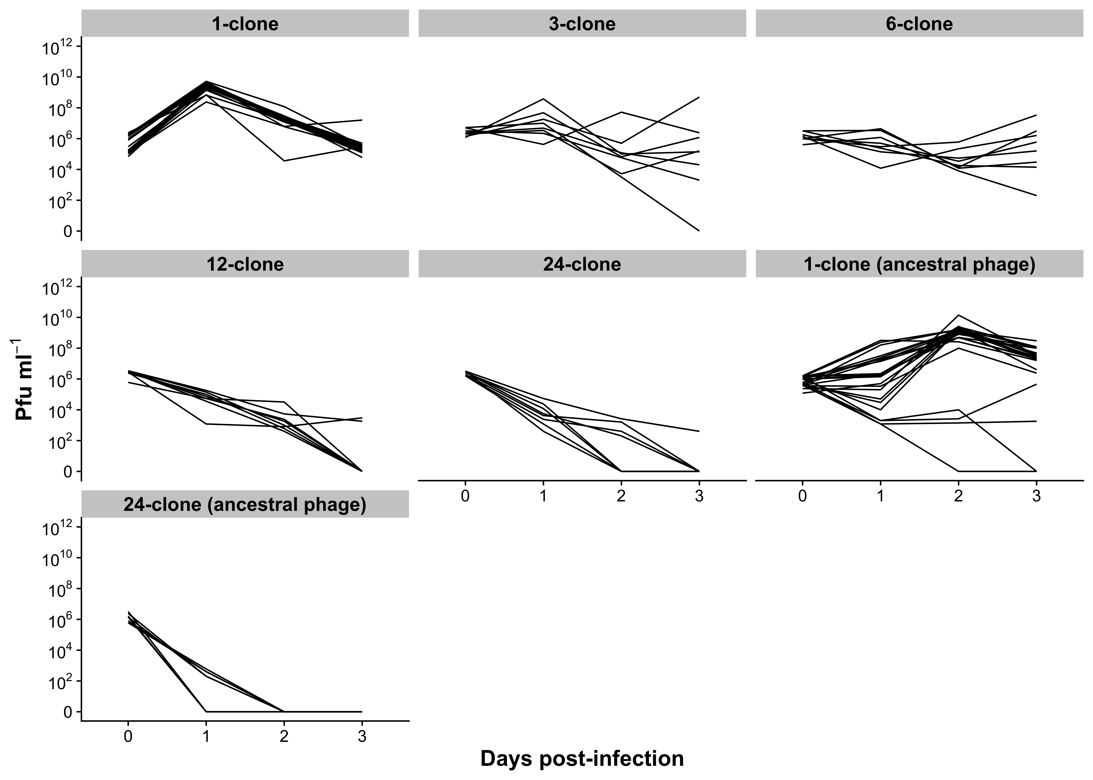

Figure 2

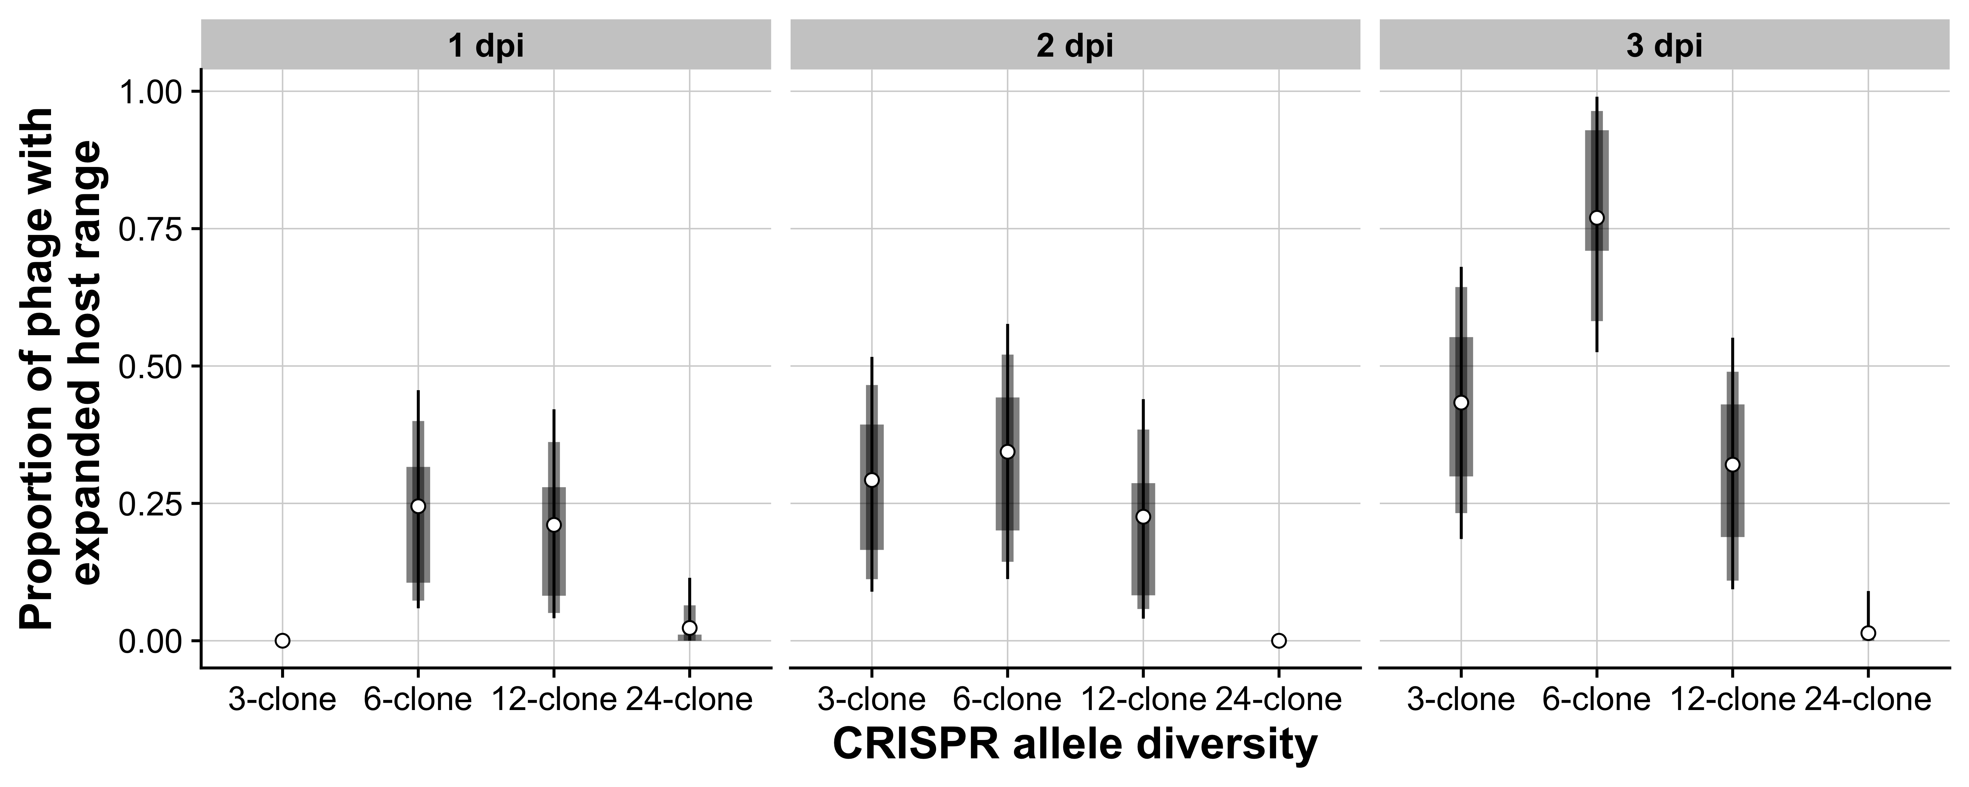

Figure 3

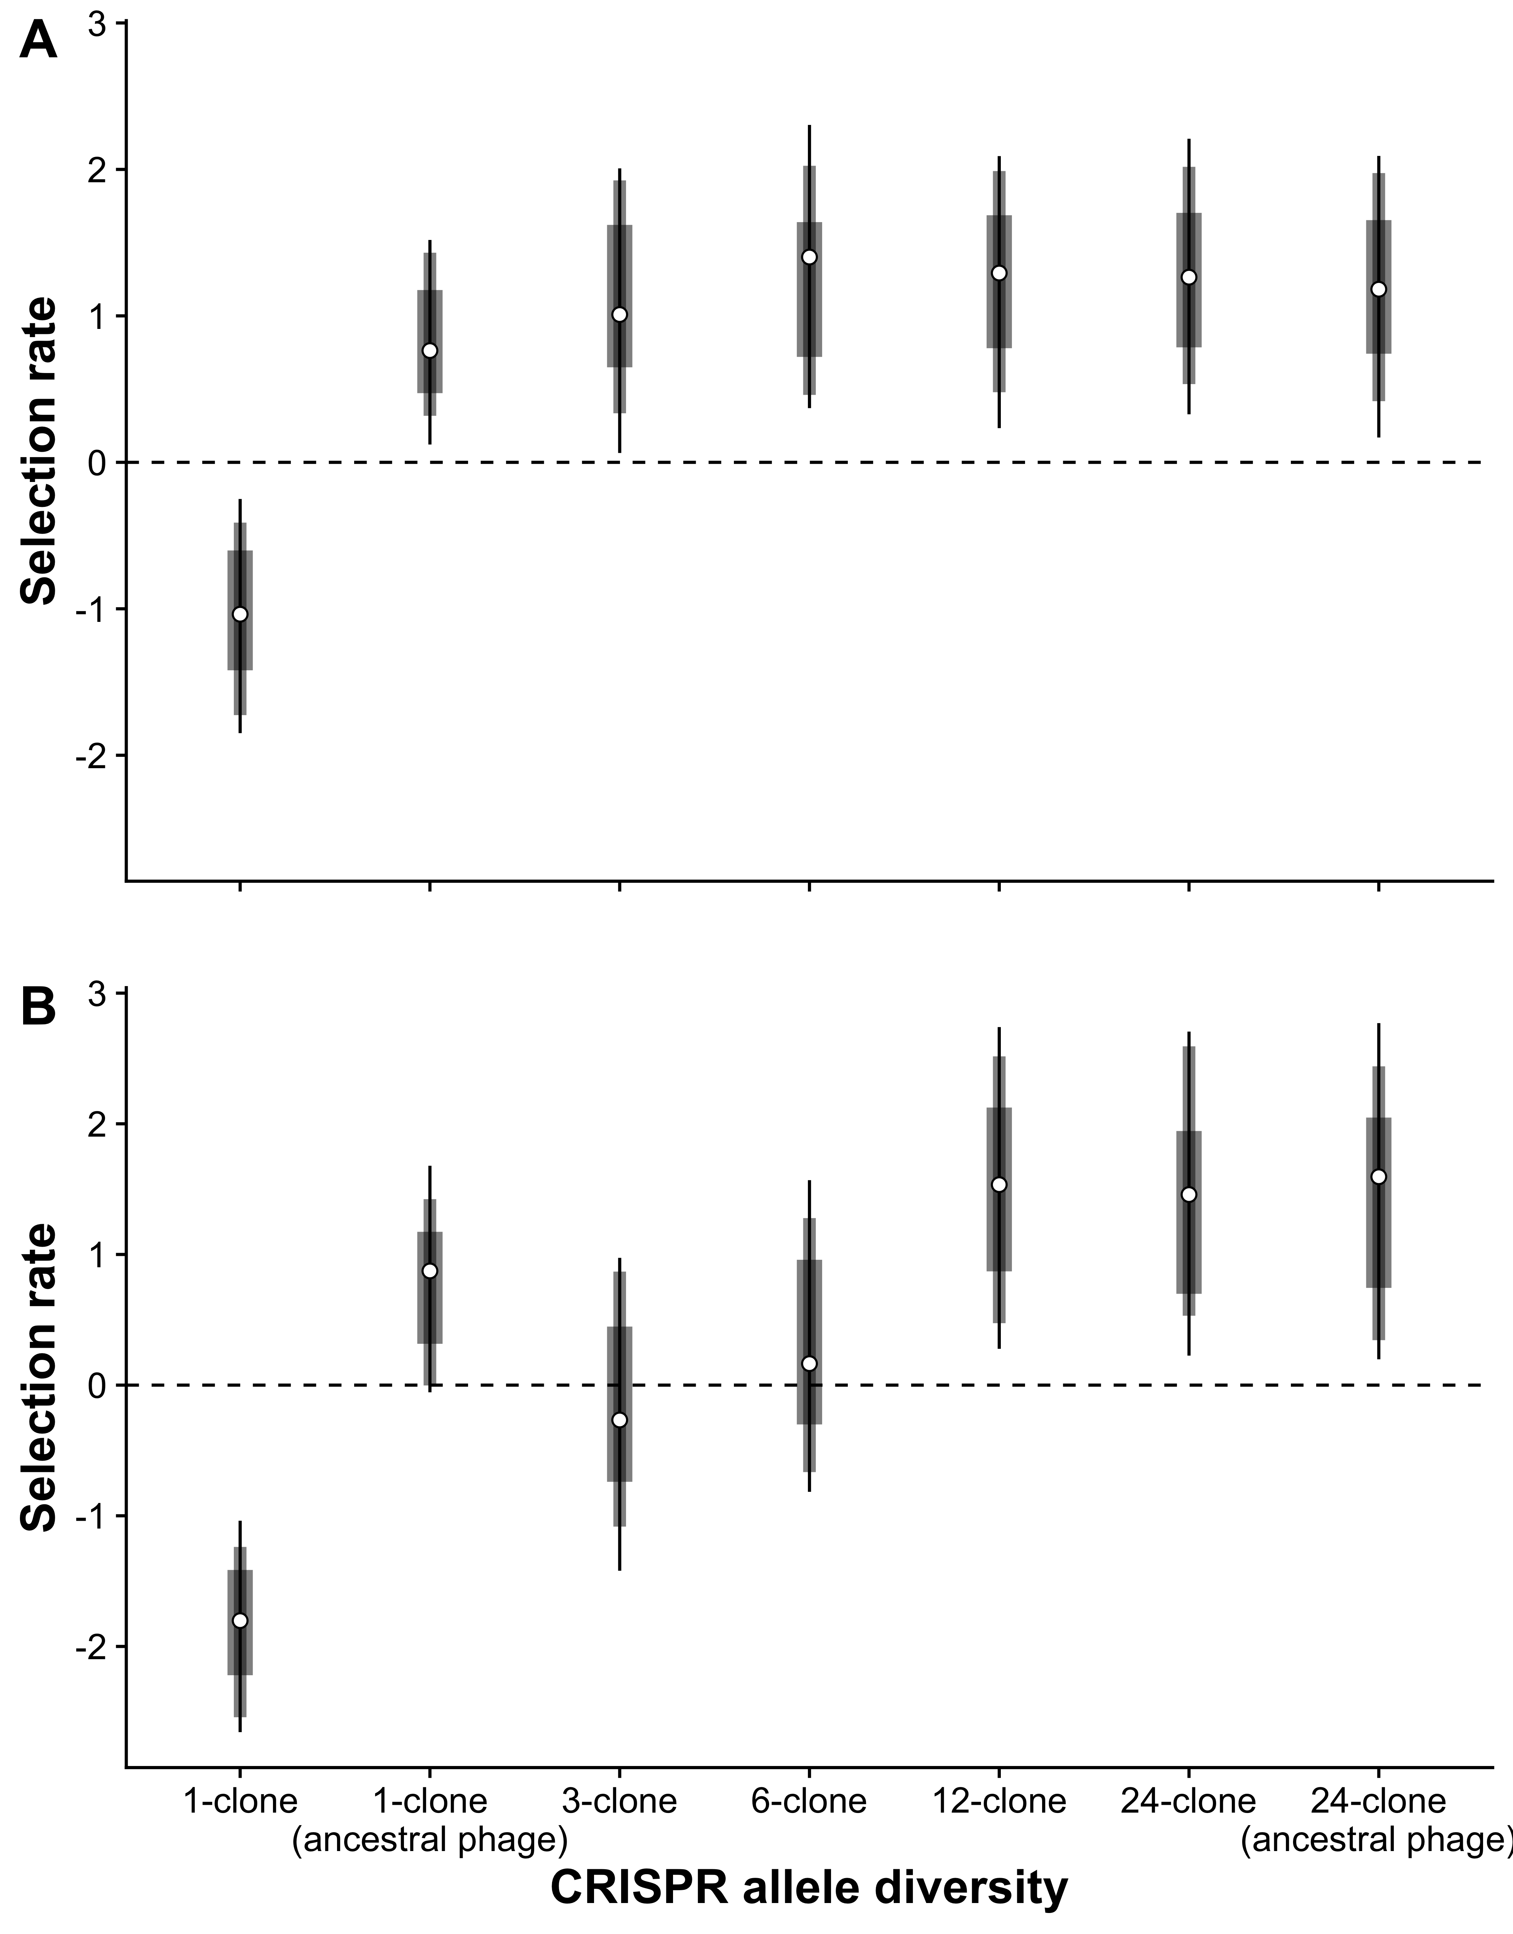

# **References**

Acevedo-Whitehouse, K., Gulland, F., Greig, D., & Amos, W. (2003). Inbreeding: disease susceptibility in California sea lions. *Nature, 422*(6927), 35.

Altermatt, F., & Ebert, D. (2008). Genetic diversity of Daphnia magna populations enhances resistance to parasites. *Ecol Lett, 11*(9), 918-928. doi:10.1111/j.1461-0248.2008.01203.x

Andersson, A. F., & Banfield, J. F. (2008). Virus population dynamics and acquired virus resistance in natural microbial communities. *Science, 320*(5879), 1047-1050. doi:10.1126/science.1157358

Antia, R., Regoes, R. R., Koella, J. C., & Bergstrom, C. T. (2003). The role of evolution in the emergence of infectious diseases. *Nature, 426*(6967), 658.

Bache, S. M., & Wickham, H. (2014). magrittr: A Forward-Pipe Operator for R (Version 1.5). Retrieved from [https://cran.r-project.org/package=magrittr](https://CRAN.R-project.org/package=magrittr)

Benmayor, R., Hodgson, D. J., Perron, G. G., & Buckling, A. (2009). Host mixing and disease emergence. *Curr Biol, 19*(9), 764-767.

Brouns, S. J. J., Jore, M. M., Lundgren, M., Westra, E. R., Slijkhuis, R. J. H., Snijders, A. P. L., . . . van der Oost, J. (2008). Small CRISPR RNAs Guide Antiviral Defense in Prokaryotes. *Science, 321*(5891), 960-964. doi:10.1126/science.1159689

Burnham, K. P., & Anderson, D. R. (2003). *Model selection and multimodel inference: a practical information-theoretic approach*. New York: Springer.

Burnham, K. P., & Anderson, D. R. (2004). Multimodel inference: understanding AIC and BIC in model selection. *Sociol Methods Res, 33*(2), 261-304.

Cady, K. C., Bondy-Denomy, J., Heussler, G. E., Davidson, A. R., & O'Toole, G. A. (2012). The CRISPR/Cas Adaptive Immune System of *Pseudomonas aeruginosa* Mediates Resistance to Naturally Occurring and Engineered Phages. *J Bacteriol, 194*(21), 5728-5738. doi:10.1128/jb.01184-12

Chabas, H., Lion, S., Nicot, A., Meaden, S., van Houte, S., Moineau, S., . . . Gandon, S. (2018). Evolutionary emergence of infectious diseases in heterogeneous host populations. *PLoS Biol, 16*(9), e2006738. doi:10.1371/journal.pbio.2006738

Civitello, D. J., Cohen, J., Fatima, H., Halstead, N. T., Liriano, J., McMahon, T. A., . . . Young, S. (2015). Biodiversity inhibits parasites: broad evidence for the dilution effect. *Proc Natl Acad Sci USA, 112*(28), 8667-8671.

Common, J., Morley, D., van Houte, S., & Westra, E. R. (2019). CRISPR-Cas immunity leads to a coevolutionary arms race between *Streptococcus* *thermophilus* and lytic phage. *Philos Trans Royal Soc B*. doi:10.1098/rstb.2018.0098

Common, J., & Westra, E. R. (2019). CRISPR evolution and bacteriophage persistence in the context of population bottlenecks. *RNA Biol*.

Datsenko, K. A., Pougach, K., Tikhonov, A., Wanner, B. L., Severinov, K., & Semenova, E. (2012). Molecular memory of prior infections activates the CRISPR/Cas adaptive bacterial immunity system. *Nat Commun, 3*, 945. doi:<http://www.nature.com/ncomms/journal/v3/n7/suppinfo/ncomms1937_S1.html>

Dennehy, J. J., Friedenberg, N. A., Holt, R. D., & Turner, P. E. (2006). Viral ecology and the maintenance of novel host use. *Am Nat, 167*(3), 429-439.

Dennehy, J. J., Friedenberg, N. A., Yang, Y. W., & Turner, P. E. (2007). Virus population extinction via ecological traps. *Ecol Lett, 10*(3), 230-240.

Deveau, H., Barrangou, R., Garneau, J. E., Labonté, J., Fremaux, C., Boyaval, P., . . . Moineau, S. (2008). Phage Response to CRISPR-Encoded Resistance in *Streptococcus thermophilus*. *J Bacteriol, 190*(4), 1390-1400. doi:10.1128/jb.01412-07

Dobson, A. (2004). Population dynamics of pathogens with multiple host species. *Am Nat, 164*(S5), S64-S78.

Eastwood, J. R., Ribot, R. F., Rollins, L. A., Buchanan, K. L., Walder, K., Bennett, A. T., & Berg, M. L. (2017). Host heterozygosity and genotype rarity affect viral dynamics in an avian subspecies complex. *Sci Rep, 7*(1), 13310.

Ebert, D., Altermatt, F., & Lass, S. (2007). A short term benefit for outcrossing in a Daphnia metapopulation in relation to parasitism. *J Royal Soc Interface, 4*(16), 777-785.

Ellison, A. M., & Adamec, L. (2011). Ecophysiological traits of terrestrial and aquatic carnivorous plants: are the costs and benefits the same? *Oikos, 120*(11), 1721-1731. doi:10.1111/j.1600-0706.2011.19604.x

Elton, C. S. (1958). *The ecology of invasions by animals and plants*. London: Methuen & Co.

Ferrieres, L., Hémery, G., Nham, T., Guérout, A.-M., Mazel, D., Beloin, C., & Ghigo, J.-M. (2010). Silent mischief: bacteriophage Mu insertions contaminate products of *Escherichia coli* random mutagenesis performed using suicidal transposon delivery plasmids mobilized by broad-host-range RP4 conjugative machinery. *J Bacteriol, 192*(24), 6418-6427.

Gandon, S. (2004). Evolution of multihost parasites. *Evolution, 58*(3), 455-469.

Ganz, H. H., & Ebert, D. (2010). Benefits of host genetic diversity for resistance to infection depend on parasite diversity. *Ecology, 91*(5), 1263-1268. doi:10.1890/09-1243.1

Garneau, J. E., Dupuis, M.-E., Villion, M., Romero, D. A., Barrangou, R., Boyaval, P., . . . Moineau, S. (2010). The CRISPR/Cas bacterial immune system cleaves bacteriophage and plasmid DNA. *Nature, 468*(7320), 67-71. doi:[http://www.nature.com/nature/journal/v468/n7320/abs/nature09523.html - supplementary-information](http://www.nature.com/nature/journal/v468/n7320/abs/nature09523.html#supplementary-information)

Henry, L., & Wickham, H. (2018). tidyr: Easily Tidy Data with 'spread()' and 'gather()' Functions [0.8.2]. Retrieved from [https://cran.r-project.org/package=tidyr](https://CRAN.R-project.org/package=tidyr)

Horvath, P., Romero, D. A., Coute-Monvoisin, A. C., Richards, M., Deveau, H., Moineau, S., . . . Barrangou, R. (2008). Diversity, activity, and evolution of CRISPR loci in *Streptococcus thermophilus*. *J Bacteriol, 190*(4), 1401-1412. doi:10.1128/JB.01415-07

Hudson, P. J., Dobson, A. P., & Lafferty, K. D. (2006). Is a healthy ecosystem one that is rich in parasites? *Trends Ecol Evol, 21*(7), 381-385.

Kearse, M., Moir, R., Wilson, A., Stones-Havas, S., Cheung, M., Sturrock, S., . . . Duran, C. (2012). Geneious Basic: an integrated and extendable desktop software platform for the organization and analysis of sequence data. *Bioinformatics, 28*(12), 1647-1649.

Keesing, F., Holt, R. D., & Ostfeld, R. S. (2006). Effects of species diversity on disease risk. *Ecol Lett, 9*(4), 485-498.

Kerstes, N. A., & Wegner, K. M. (2011). The effect of inbreeding and outcrossing of Tribolium castaneum on resistance to the parasite Nosema whitei. *Evol Ecol Res, 13*(7), 681-696.

King, K. C., Delph, L. F., Jokela, J., & Lively, C. M. (2011). Coevolutionary hotspots and coldspots for host sex and parasite local adaptation in a snail–trematode interaction. *Oikos, 120*(9), 1335-1340. doi:10.1111/j.1600-0706.2011.19241.x

Lenski, R. E. (1991). Quantifying fitness and gene stability in microorganisms. *Biotechnology, 15*, 173-192.

Lively, C. M. (2010). The Effect of Host Genetic Diversity on Disease Spread. *Am Nat, 175*(6), E149-E152. doi:10.1086/652430

López-Uribe, M. M., Appler, R. H., Youngsteadt, E., Dunn, R. R., Frank, S. D., & Tarpy, D. R. (2017). Higher immunocompetence is associated with higher genetic diversity in feral honey bee colonies (Apis mellifera). *Conserv Genet, 18*(3), 659-666.

Luijckx, P., Fienberg, H., Duneau, D., & Ebert, D. (2013). A Matching-Allele Model Explains Host Resistance to Parasites. *Curr Bio*.

Marraffini, L. A., & Sontheimer, E. J. (2008). CRISPR interference limits horizontal gene transfer in staphylococci by targeting DNA. *Science, 322*(5909), 1843-1845.

Martínez-García, E., Aparicio, T., de Lorenzo, V., & Nikel, P. I. (2014). New transposon tools tailored for metabolic engineering of Gram-negative microbial cell factories. *Front Bioeng Biotech, 2*, 46.

McGill, B. J., Etienne, R. S., Gray, J. S., Alonso, D., Anderson, M. J., Benecha, H. K., . . . He, F. (2007). Species abundance distributions: moving beyond single prediction theories to integration within an ecological framework. *Ecol Lett, 10*(10), 995-1015.

Meagher, S. (1999). Genetic diversity and Capillaria hepatica (Nematoda) prevalence in Michigan deer mouse populations. *Evolution, 53*(4), 1318-1324.

Mojica, F. J., Diez-Villasenor, C., Garcia-Martinez, J., & Almendros, C. (2009). Short motif sequences determine the targets of the prokaryotic CRISPR defence system. *Microbiology, 155*(Pt 3), 733-740. doi:10.1099/mic.0.023960-0

Morley, D., Broniewski, J. M., Westra, E. R., Buckling, A., & van Houte, S. (2017). Host diversity limits the evolution of parasite local adaptation. *Mol Ecol, 26*(7), 1756-1763.

O'Brien, S. J., Roelke, M. E., Marker, L., Newman, A., Winkler, C., Meltzer, D., . . . Wildt, D. E. (1985). Genetic basis for species vulnerability in the cheetah. *Science, 227*(4693), 1428-1434.

Ohtsuki, A., & Sasaki, A. (2006). Epidemiology and disease-control under gene-for-gene plant–pathogen interaction. *J Theor Biol, 238*(4), 780-794.

Ostfeld, R. S., & Keesing, F. (2012). Effects of host diversity on infectious disease. *Annu Rev Ecol Evol Syst, 43*.

Pachepsky, E., Crawford, J. W., Bown, J. L., & Squire, G. (2001). Towards a general theory of biodiversity. *Nature, 410*(6831), 923.

Paez-Espino, D., Morovic, W., Sun, C. L., Thomas, B. C., Ueda, K.-i., Stahl, B., . . . Banfield, J. F. (2013). Strong bias in the bacterial CRISPR elements that confer immunity to phage. *Nat Commun, 4*, 1430.

Paez-Espino, D., Sharon, I., Morovic, W., Stahl, B., Thomas, B. C., Barrangou, R., & Banfield, J. F. (2015). CRISPR immunity drives rapid phage genome evolution in Streptococcus thermophilus. *MBio, 6*(2). doi:10.1128/mBio.00262-15

Pearman, P. B., & Garner, T. W. (2005). Susceptibility of Italian agile frog populations to an emerging strain of Ranavirus parallels population genetic diversity. *Ecol Lett, 8*(4), 401-408.

R Core Team. (2018). R: A language and environment for statistical computing (Version 3.5.2 "Eggshell Igloo"). Vienna, Austria: R Foundation for Statistical Computing. Retrieved from [http://www.r-project.org/](http://www.R-project.org/)

Sasaki, A. (2000). Host-parasite coevolution in a multilocus gene-for-gene system. *Proc Royal Soc B 267*(1458), 2183-2188.

Semenova, E., Jore, M. M., Datsenko, K. A., Semenova, A., Westra, E. R., Wanner, B., . . . Severinov, K. (2011). Interference by clustered regularly interspaced short palindromic repeat (CRISPR) RNA is governed by a seed sequence. *Proc Natl Acad Sci USA, 108*(25), 10098-10103. doi:10.1073/pnas.1104144108

Spielman, D., Brook, B. W., Briscoe, D. A., & Frankham, R. (2004). Does inbreeding and loss of genetic diversity decrease disease resistance? *Conserv Genet, 5*(4), 439-448.

Sun, C. L., Thomas, B. C., Barrangou, R., & Banfield, J. F. (2016). Metagenomic reconstructions of bacterial CRISPR loci constrain population histories. *ISME J, 10*(4), 858-870. doi:10.1038/ismej.2015.162

Telfer, S., Lambin, X., Birtles, R., Beldomenico, P., Burthe, S., Paterson, S., & Begon, M. (2010). Species interactions in a parasite community drive infection risk in a wildlife population. *Science, 330*(6001), 243-246.

Thorne, E. T., & Williams, E. S. (1988). Disease and endangered species: the black‐footed ferret as a recent example. *Conserv Biol, 2*(1), 66-74.

Travisano, M., & Lenski, R. E. (1996). Long-term experimental evolution in Escherichia coli. IV. Targets of selection and the specificity of adaptation. *Genetics, 143*(1), 15-26.

van Houte, S., Ekroth, A. K. E., Broniewski, J. M., Chabas, H., Ashby, B., Bondy-Denomy, J., . . . Westra, E. R. (2016). The diversity-generating benefits of a prokaryotic adaptive immune system. *Nature, 532*(7599), 385-388. doi:10.1038/nature17436

Westra, E. R., Semenova, E., Datsenko, K. A., Jackson, R. N., Wiedenheft, B., Severinov, K., & Brouns, S. J. (2013). Type IE CRISPR-cas systems discriminate target from non-target DNA through base pairing-independent PAM recognition. *PLoS Genet, 9*(9), e1003742.

Westra, E. R., Sünderhauf, D., Landsberger, M., & Buckling, A. (2017). Mechanisms and consequences of diversity-generating immune strategies. *Nat Rev Immunol, 17*(11), 719.

Westra, E. R., van Houte, S., Oyesiku-Blakemore, S., Makin, B., Broniewski, Jenny M., Best, A., . . . Buckling, A. (2015). Parasite Exposure Drives Selective Evolution of Constitutive versus Inducible Defense. *Curr Biol, 25*(8), 1043-1049. doi:10.1016/j.cub.2015.01.065

Whiteman, N. K., Kimball, R. T., & Parker, P. G. (2007). Co‐phylogeography and comparative population genetics of the threatened Galápagos hawk and three ectoparasite species: ecology shapes population histories within parasite communities. *Mol Ecol, 16*(22), 4759-4773.

Wickham, H. (2009). ggplot2: Elegant Graphics for Data Analysis: Springer-Verlag New York. Retrieved from [http://ggplot2.org/](http://ggplot2.org)

Wickham, H., François, R., Henry, L., & Mûller, K. (2018). dplyr: A Grammar of Data Manipulation (Version 0.7.8). Retrieved from [https://cran.r-project.org/package=dplyr](https://CRAN.R-project.org/package=dplyr)

Yates, A., Antia, R., & Regoes, R. R. (2006). How do pathogen evolution and host heterogeneity interact in disease emergence? *Proc Royal Soc B, 273*(1605), 3075-3083.

Zegans, M. E., Wagner, J. C., Cady, K. C., Murphy, D. M., Hammond, J. H., & O'Toole, G. A. (2009). Interaction between bacteriophage DMS3 and host CRISPR region inhibits group behaviors of *Pseudomonas aeruginosa*. *J Bacteriol, 191*(1), 210-219.

Zhu, Y., Chen, H., Fan, J., & Wang, Y. (2000). Genetic diversity and disease control in rice. *Nature, 406*(6797), 718.